CONNECTED, LEVEL 4 2014, What’s the Evidence?  The Great Marble Challenge  by Ian Stevens  Overview  A teacher challenges his class to design a ramp that will get a marble to stop at any set distance between 500 millimetres and 2 metres from the end of the ramp. The text follows the process the students go through to meet this challenge.  The illustrated descriptions scaffold readers to engage with the text and to try the activity themselves. The instructional strategies provide support for this complex text.  A Google Slides version of this article is available at www.connected.tki.org.nz. |  |  | 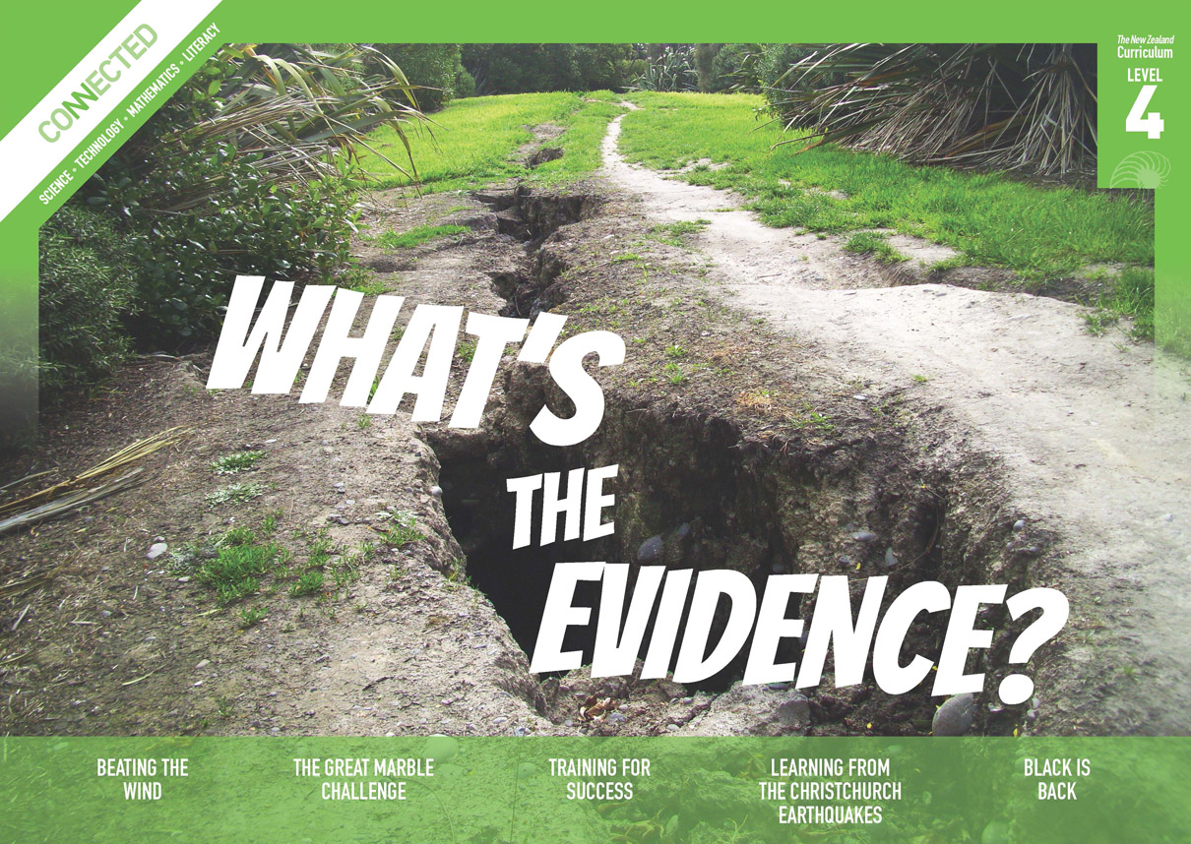  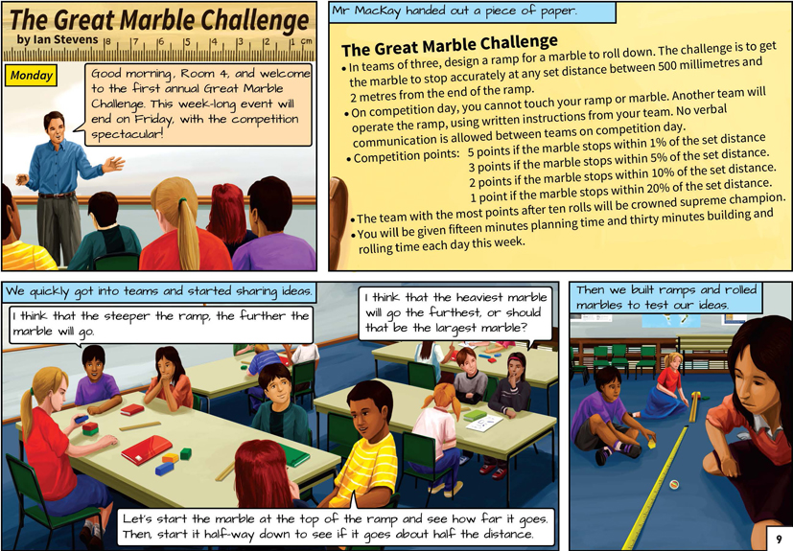

Text characteristics
- A graphic story, with much of the information conveyed visually
- Illustrations, graphs, and data tables that clarify or extend the text and may require some interpretation
- Mathematical vocabulary and terminology.

Curriculum context

MATHEMATICS AND STATISTICS
STATISTICS: Statistical investigation  Achievement objective(s)  L4: Students will plan and conduct investigations using the statistical enquiry cycle:  - determining appropriate variables and data collection methods;  - gathering, sorting, and displaying multivariate category, measurement, and time-series data to detect patterns, variations, relationships, and trends;  - comparing distributions visually;  - communicating findings, using appropriate displays. |  | STATISTICS: Statistical literacy  Achievement objective(s)  L4: Students will evaluate statements made by others about the findings of statistical investigations and probability activities.  STATISTICS: Probability  Achievement objective(s)  L4: Students will investigate situations that involve elements of chance by comparing experimental distributions with expectations from models of the possible outcomes, acknowledging variation and independence. |  |  | Key statistical ideas  - Data can be used for different purposes.  - Data can be used to predict a future event.  - Organising data and looking for patterns and trends can reveal useful information.
GEOMETRY AND MEASUREMENT: Measurement  Achievement objective(s)  L4: Students will:  - Use appropriate scales, devices, and metric units for length, area, volume and capacity, weight (mass), temperature, angle, and time.  - Convert between metric units, using whole numbers and commonly used decimals.  - Interpret and use scales, timetables, and charts. |  | GEOMETRY AND MEASUREMENT: Position and orientation  Achievement objective(s)  L4: Students will communicate and interpret locations and directions, using compass directions, distances, and grid references.

ENGLISH

READING  Ideas  Students will show an increasing understanding of ideas within, across, and beyond texts. |  | INDICATORS  - Makes meaning of increasingly complex texts by identifying and understanding main and subsidiary ideas and the links between them.  - Makes connections by thinking about underlying ideas within and between texts from a range of contexts.  - Recognises that there may be more than one reading available within a text.  - Makes and supports inferences from texts with increasing independence. |  | THE LITERACY LEARNING PROGRESSIONS  The literacy knowledge and skills that students need to draw on by the end of year 8 are described in The Literacy Learning Progressions.

Meeting the literacy challenges

The following instructional strategies will support students to understand, respond to, and think critically about the information and ideas in the text. After reading the text, support students to explore the key statistical ideas outlined in the following pages.

TEACHER resources

Want to know more about instructional strategies? Go to:
- http://literacyonline.tki.org.nz/Literacy-Online/Teacher-needs/Reviewed-resources/Reading/Comprehension/ELP-years-5-8
- “Engaging Learners with Texts” (Chapter 5) from Effective Literacy Practice in Years 1 to 4 (Ministry of Education, 2003).
Want to know more about what literacy skills and knowledge your students need? Go to:
- http://literacyonline.tki.org.nz/Literacy-Online/Student-needs/National-Standards-Reading-and-Writing
- www.literacyprogressions.tki.org.nz/
“Working with Comprehension Strategies” (Chapter 5) from Teaching Reading Comprehension (Davis, 2007) gives comprehensive guidance for explicit strategy instruction in years 4–8.
Teaching Reading Comprehension Strategies: A Practical Classroom Guide (Cameron, 2009) provides information, resources, and tools for comprehension strategy instruction.

INSTRUCTIONAL STRATEGIES

FINDING THE MAIN IDEAS
ASK QUESTIONS to help the students identify the main ideas.
What does the title suggest the article is about?
How do the visual features (such as graphs and data tables) on pages 11–13 support your predictions about the content?
What different forms of measurement do you notice?
Why is measurement important in this article?
EXPLAIN that there is a lot of information in this article, so a good way to keep track of it is to summarise it. Try using a graphic organiser like this to record the main ideas.

 | Monday | Tuesday | Wednesday | Thursday | Friday
What the groups learned

PROMPT the students to notice the way this article is set out in diary form and think about why this layout was a good choice.

USING DESIGN FEATURES FOR DEEPER UNDERSTANDING
This text requires readers to repeatedly shift their focus from the text to the illustrations, data tables, and graphs. Remind the students that the tables and graphs provide crucial information. ASK QUESTIONS to help them find the meaning in the visual information.
- What can you learn simply by looking at the illustrations?
- What is the purpose of the data tables and graphs?
At the bottom of page 12, there are explanations of how to read the table and number line. Have the students read them closely and then use them to find out where the marble should be rolled from to make it a go a certain distance. They can do this in pairs, taking turns to suggest a distance. If necessary, MODEL what to do. Then have them write instructions for rolling the marble a certain distance.
On a second reading, provide the students with ramps, blocks, and marbles. Put them in teams. Have each team use one group’s set of instructions to test their clarity and to note other details they would need. PROMPT them to display the results in an appropriate way and to report them to the rest of the class.
- How clear were the instructions?
- How might you have improved them?

DEALING WITH SCIENTIFIC AND MATHEMATICAL VOCABULARY
IDENTIFY the mathematical vocabulary that may challenge students, for example, “accurate”, “variation”, “variable”, “predict”, “experimental probability”, “range”, “data”, “x-axis”, “y-axis”, “relationship”.
PROMPT the students to work in small groups to write definitions for each term, using their prior knowledge, information from the text, and classroom resources such as dictionaries. Have them illustrate the terms with an example of their use. DISCUSS the definitions, agreeing on a short glossary that will become part of the regular classroom language.
To reinforce this learning, give the students a card like this. EXPLAIN that this is a game called Forbidden Words. The idea is for one player to describe an object, idea, or phrase without using certain forbidden words. The other players have to try and guess the word.
Accurate

Precise
Exact

You can read more about this game at www.subtangent.com/maths/resources/forbidden-words.pdf

Key statistical ideas
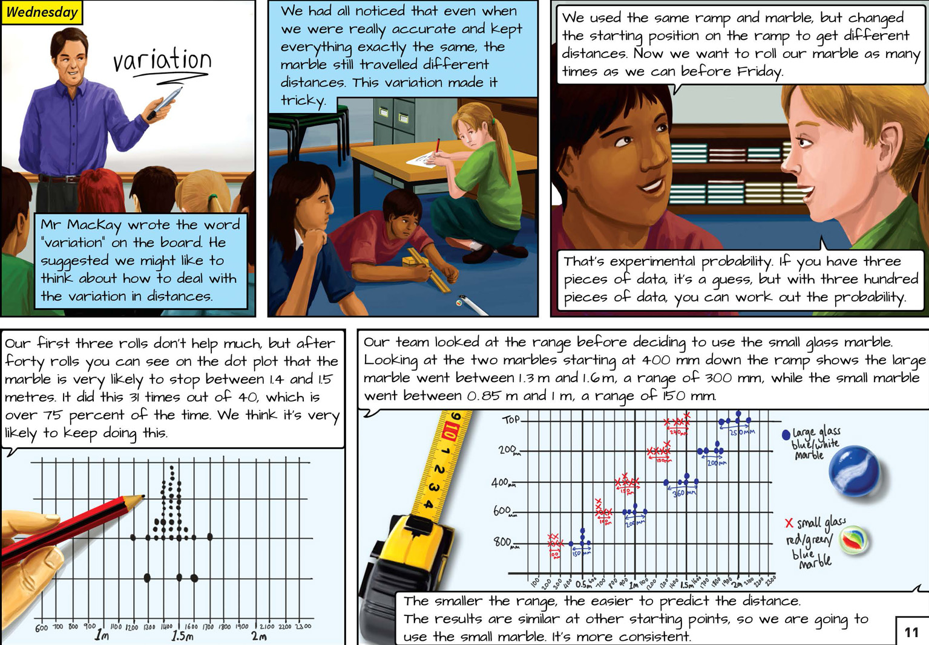 | Students plan and conduct investigations using the statistical enquiry cycle.  Data can be used to predict a future event.  Students investigate situations that involve elements of chance by acknowledging variation.
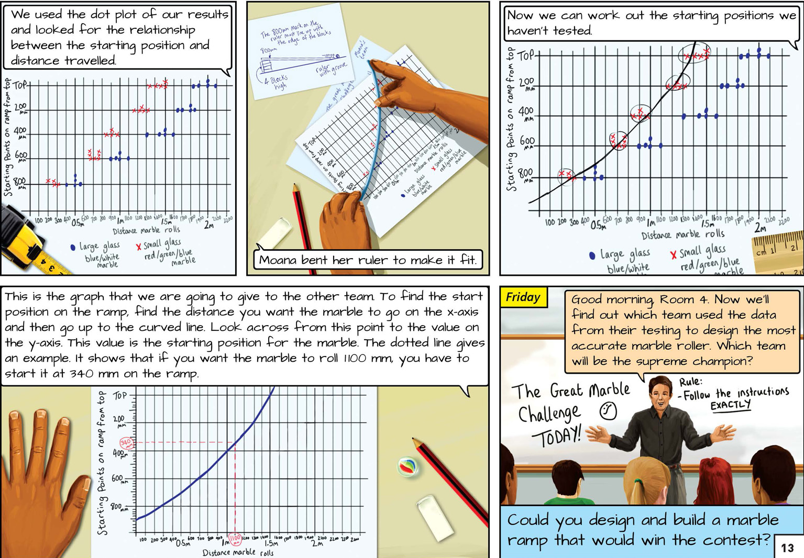 | Students communicate and interpret information using scales and graphs.  Organising data and looking for patterns and trends can reveal useful information.

Exploring the mathematics and statistics
The following activities are a guide for supporting students to develop capabilities relating to gathering and interpreting data, statistical thinking, and problem solving. You are encouraged to adapt the activities to suit the specific needs of your students.

LEARNING FOCUS
Selecting, gathering, and using data for a specific purpose.

LEARNING ACTIVITIES

Activity 1: Marble challenge!
Your students could hold their own marble challenge, following a similar procedure to the one in the article. The “Marble Roll” activity on the NZ Maths site (www.nzmaths.co.nz/resource/marble-roll) sets out detailed instructions and provides copymasters for “scatter graphs”.
A scatter graph plots points to show the relationship between two variables. Each point represents one marble roll, showing the variable of the starting distance from the top of the ramp (y axis) and the variable of the distance the marble rolls from the end of the ramp (x axis).
A dot chart or dot plot plots points to show one variable using a number line. For example: each point represents one marble roll and the position on the number line represents the distance travelled.
Have the students keep a log book of their actions and decisions as they develop their marble tracks. Encourage them to include reflective comments about their ideas, decisions, changes, successes, and failures.
A similar level 3 activity from the NZ Maths site is “On a Slippery Slope” (www.nzmaths.co.nz/resource/slippery-slope-0).

Activity 2: Dynamic darts
“Dynamic Darts” is an activity from the Figure It Out series (www.nzmaths.co.nz/resource/dynamic-darts) in which students conduct statistical enquiries into the best design for a paper dart. There are five parts of the enquiry cycle:
Problem: Decide what we are trying to find out. For example, which type of dart stays in the air the longest?
Plan: Decide what to measure and why, as well as how to collect the data to answer the question.
Data: Collect and record data from flying the darts.
Analysis: Sort and display the data, looking for patterns and suggesting hypotheses.
Conclusion: Communicate what has been found out and identify possible new problems that could be investigated (that is, cycling around the enquiry cycle again). For example, if we change the angle of the wings on our current dart, would it stay in the air longer?
Use the writing frame example on the NZ Maths site (www.nzmaths.co.nz/resource/dynamic-darts) to support the students to write a report explaining the process they undertook and the final outcome.
The “Are You a Data Detective?” poster from the CensusAtSchool New Zealand site outlines the statistical enquiry cycle (http://new.censusatschool.org.nz/wp-content/uploads/2012/11/data-detective1.pdf).

Activity 3: Action and reaction
“Action and Reaction” is a Figure it Out activity (http://www.nzmaths.co.nz/resource/action-and-reaction) in which students work in pairs and measure their reaction times. They record each person's results for a set of ten trials. They work out the mean, median, and mode for each person. They then collate the median reaction length for the whole class and present this on a histogram and a box-and-whisker plot. Finally, they compare the graphs, discussing what each shows.
When might you choose to use a histogram?
When might you choose to use a box-and-whisker plot?
Google Slides version of “The Great Marble Challenge” www.connected.tki.org.nz

extension ACTIVITIES

Use Marbles: Exploring Motion and Forces, Building Science Concepts book 42, to further explore the concept of motion and how it is affected by gravity and friction.
Read “The Big Race” in Connected 2, 2006. In this article, Lola discovers Grandpa’s old swimming medal, a prize that resulted from many hours of training. The teacher support material (link below) suggests how to help students explore the maths behind Grandpa’s training schedule and the handicapping system devised to keep everyone training hard for the big race.

RESOURCE LINKS

“The Big Race” by Dale Hendry. From Connected 2, 2006. (TSMs available from http://literacyonline.tki.org.nz/Literacy-Online/Teacher-needs/Instructional-Series/Connected/2004-2009-TSM)
Building Science Concepts, Book 42 – Marbles: Exploring Motion and Forces

“Rolling Marbles II” from Science Online at http://scienceonline.tki.org.nz/Introducing-five-science-capabilities/Gather-interpret-data/Rolling-marbles-II
“Student Activity – Racing Marbles” from the Science Learning Hub www.sciencelearn.org.nz/Science-Stories/Strange-Liquids/Racing-marbles
New Zealand Maths
“Marble Roll” at www.nzmaths.co.nz/resource/marble-roll
“Dynamic Darts” in Figure It Out: Technology in Practice (Levels 3+–4+) www.nzmaths.co.nz/resource/dynamic-darts
“Action and Recreation” in Figure It Out: Statistics Book 2 (Level 4+) www.nzmaths.co.nz/resource/action-and-reaction
“On the Slippery Slope” in Figure It Out: Theme: Sport (Level 3–4) www.nzmaths.co.nz/resource/slippery-slope-0
“Rolling Marbles” from www.nzmaths.co.nz/resource/rolling-marbles
Assessment Resource Bank (ARB)
“Rolling Marbles (PW3688)” at http://arb.nzcer.org.nz/resources/science/physical/3000/pw3688.htm
“Rolling Marbles (PW3690)” at http://arb.nzcer.org.nz/resources/science/physical/3000/pw3690.htm
“Rolling Marbles II (PW4111)” at http://arb.nzcer.org.nz/resources/science/physical/4000/pw4111.htm
“Are You a Data Detective?” from CensusAtSchool New Zealand, http://new.censusatschool.org.nz/wp-content/uploads/2012/11/data-detective1.pdf

